ASSIGNMENT COVERSHEET

UTS: ENGINEERING & INFORMATION TECHNOLOGY
SUBJECT NUMBER & NAME  41052 Advanced Algorithms | NAME OF STUDENT(s) (PRINT CLEARLY)  KING-EO Colin Ice  SURNAME FIRST NAME |  |  |  |  |  | STUDENT ID(s)  2565 0223
STUDENT EMAIL  ColinIce.R.King-Eo@student.uts.edu.au |  |  |  | STUDENT CONTACT NUMBER  0466353024
NAME OF TUTOR |  |  | TUTORIAL GROUP  01 |  |  | DUE DATE  30 September, 2026
ASSESSMENT ITEM NUMBER & TITLE
41052 Advanced Algorithms - Programming Assignment 1: Algorithm Implementation Project

I acknowledge that if AI or another nonrecoverable source was used to generate materials for background research and self-study in producing this assignment, I have checked and verified the accuracy and integrity of the information used.
I confirm that I have read, understood and followed the guidelines for assignment submission and presentation on page 2 of this cover sheet.
I confirm that I have read, understood and followed the advice in the Subject Outline about assessment requirements.
I understand that if this assignment is submitted after the due date it may incur a penalty for lateness unless I have previously had an extension of time approved and have attached the written confirmation of this extension.

Declaration of originality: The work contained in this assignment, other than that specifically attributed to another source, is that of the author(s) and has not been previously submitted for assessment. I have rewritten any material provided by AI or other nonrecoverable sources and where appropriate acknowledged their contribution. I understand that, should this declaration be found to be false, disciplinary action could be taken and penalties imposed in accordance with University policy and rules. In the statement below, I have indicated the extent to which I have collaborated with others, whom I have named.

No content generated by AI technologies or other sources has been presented as my own work and I have rewritten any text provided by AI or other sources in my own words.

Statement of collaboration:

I declare here that the use of AI, primarily OpenAI’s ChatGPT and Codex programming LLM, exists in this assignment extensively since its expected given the nature of such a project. Part of the report will elaborate on the use of AI in the completion of the assignment.

Signature of student(s) Colin Ice King-eo Date _________________________

- -- - - - - - - - - - - - - - - - - - - - - - - - - - - - - - - - - - - - - - - - - - - - - - - - - - - - - - - - - - - - - - - - - - - - - - - - - - - - - - - - - - - - - - - - - - - - - - - - - - - -
ASSIGNMENT RECEIPT |  |  |  | To be completed by the student if a receipt is required
SUBJECT NUMBER & NAME |  | NAME OF TUTOR
SIGNATURE OF TUTOR |  |  |  |  | RECEIVED DATE

STYLE GUIDE for ASSIGNMENT SUBMISSION
Before submitting an assignment, you should refer to the policies and guidelines set out in the following:
- FEIT Student Guide
- UTS Library - referencing
- HELPS - English and academic literacy support
- UTS GSU - coursework assessment policy and procedures

Unless your Subject Coordinator has indicated otherwise in the Subject Outline, you must follow the instructions below for submission of assignments in the Faculty of Engineering and Information Technology.  Writing style  It is usually best to write your initial draft in the default settings of your software without formatting. Use the following guides in your writing.  Purpose and audience: use the correct genre and language style expected for the particular task.  Language: use ‘plain English’ for all technical writing. More information about this language style can be found at www.plainenglish.co.uk/free-guides.html.  Use spelling and grammar software tools to check your writing. Edit your document.  Standards: always use:  - Australian spelling standards (Macquarie Dictionary)  - SI (International System of Units) units of measurement  - ISO (International Organisation for Standardisation) for writing dates and times for international documents. For example yyyy-mm-dd or hh-mm-ss. However, for most applications it is more helpful to present the date in full as 26 August 2016.  Graphics and tables should:  - be numbered  - have an appropriate heading and/or caption  - be fully labelled  - be correctly referenced.  Presentation  Unless otherwise instructed, all assignment submissions should be word processed using spell-check and grammar-check software. Work should be well edited before submission. Use the following default settings:  Page setup: set margins at no less than 20mm all around.  Paper: print on A4 bond, double-spaced and preferably double-sided, left justified. | Font: use the software default style to provide consistency. The recommended style includes:  - 10-12 pt font  - consistent formatting with a limited number of fonts  - lines no more than 60 characters (use wider margins or columns if you need to make lines shorter)  Header should include:  - your name and student number  - the title of the paper or task.  Footer should include the page number and current date.  Cover sheet and statement of originality: all work submitted for assessment must be the original work of the student(s) submitting the work. A standard faculty cover sheet (see over) must be attached to the front of the submission. Any collaboration between the submitting student and others must be declared on the cover sheet.  Referencing  All sources of information used in the preparation of your submission must be acknowledged using the APA system of referencing. This includes all print, video, electronic sources.  Phrases, sentences or paragraphs taken verbatim from a source must be in quotation marks and the source(s) cited using both in-text referencing and a reference list.  Plagiarism is the failure to acknowledge sources of information. You should be fully aware of the meaning of plagiarism and its consequences both to your marks, position at the university and criminal liability. The plagiarism in your assignment submissions can be assessed both in hard copy and in soft copy through software such as Turnitin.  The UTS Library and UTS HELPS (web links above) provide extensive information for students on referencing correctly to support you in avoiding plagiarism.

Deamortising Dynamic Array Growth: A C++ Implementation and Empirical Comparison with std::vector
A Written Report for Programming Assignment 1: Algorithm Implementation Project
by Colin Ice King-eo

What I Built
Purpose and Functionality
For this project, I implemented a resizable array data structure in C++20. The data structure, named ResizableArray<T>, provides a limited interface similar to std::vector, including push_back, emplace_back, indexed access, bounds-checked access, front, back, size, empty, and clear. The main difference is that the custom structure is designed to provide worst-case (O(1)) push_back under a documented unit-cost computational model. By comparison, std::vector::push_back has amortised (O(1)) complexity because an insertion that exceeds the current capacity may need to allocate a larger buffer and move all existing elements into it.

Language and Data Representation
The main implementation is contained in include/resizable_array.hpp. I used a class template so that the structure could store different element types rather than being restricted to the integers used in the empirical study. The implementation manages raw, uninitialised storage through std::allocator. This was necessary because allocating a buffer using an ordinary array could construct every unused element immediately, which would make the cost of allocating a larger buffer depend on its capacity. With raw storage, the implementation constructs only the elements that logically belong to the array and destroys each object when it is no longer needed. This design also required explicit handling of object construction, destruction, copying, moving, and memory ownership.

A textbook dynamic array normally stores its elements in one contiguous buffer. When that buffer becomes full, it allocates a larger one and transfers every element in a single operation. My implementation replaces this approach with incremental migration. It maintains a current or new buffer, represented by data_, and may also maintain an old buffer, represented by old_data_, while migration is taking place. Additional state variables record the logical size of the array, the capacities of both buffers, the number of elements that existed when migration began, and how many of those elements have already been transferred.

Incremental Migration and Append() Complexity
Migration begins when the current buffer reaches half of its capacity rather than waiting until it is completely full. If the current capacity is (C), the implementation allocates a replacement buffer with capacity (2C) when the logical size reaches (C/2). It then migrates at most one existing element during each following insertion. Since there are (C/2) existing elements to transfer and another (C/2) elements can be appended before the logical size reaches (C), the migration can finish before another growth operation is needed. Each append therefore constructs the new element and performs at most one additional element transfer. Under the unit-cost model used by this project, this is a fixed amount of work and gives push_back worst-case (O(1)) complexity.

This complexity result depends on several theoretical assumptions. Allocating or deallocating one raw buffer is treated as a constant-time operation, as is constructing, copying, moving, or destroying one element. These assumptions are useful for analysing the algorithm, but they do not create a strict wall-clock guarantee. Real allocation time can be influenced by the operating system, allocator implementation, paging, cache behaviour, and the size or behaviour of the stored element type. For this reason, the report distinguishes the algorithmic guarantee from the practical performance measured in the empirical study.

Indexed Access During Migration
During migration, the logical array is divided into three regions. Elements with indices smaller than migrated_ have already been transferred into the new buffer. Elements from migrated_ up to migration_size_ remain in the old buffer. Elements with indices greater than or equal to migration_size_ are new insertions that were constructed directly in the new buffer. The private element_at operation uses these boundaries to select the correct physical buffer. Only a constant number of comparisons and one pointer-indexing operation are required, so indexed access remains worst-case (O(1)) even when the logical array is divided between two buffers.

Simplifications and Memory Trade-offs
This representation preserves the logical insertion order, but it does not always preserve physical contiguity. A standard std::vector can provide a pointer to one continuous sequence of elements through data(). My implementation deliberately omits data() because its elements may occupy two different allocations during migration. It also does not provide iterators, arbitrary-position insertion, erasure, reserve, or pop_back. These omissions keep the project focused on append, indexed access, memory management, and the comparison between amortised and deamortised growth. Therefore, ResizableArray<T> should be treated as an experimental vector-like structure rather than a complete replacement for std::vector.

The two-buffer design also creates a memory trade-off. While migration is active, the old buffer of capacity (C) and the new buffer of capacity (2C) coexist. The implementation therefore has (3C) allocated element slots during this period, even though the logical array contains between approximately (C/2) and (C) elements. This is still (O(n)) space, but the constant factor can be much larger than that of std::vector. Once migration finishes, the old buffer is deallocated, reducing the amount of allocated storage. This changing memory pattern is measured as part of the empirical study.

Memory Ownership and Exception Handling
Memory ownership required several additional design decisions. The class implements copy construction, move construction, copy assignment, and move assignment. Copying normalises the destination into one new buffer, regardless of whether the source is currently migrating. Moving transfers ownership of both buffers and resets the source object so that the same memory cannot be destroyed twice. When transferring an element during migration, the implementation uses a move operation when moving is guaranteed not to throw or when copying is unavailable. Otherwise, it copies the element to reduce the risk of modifying the source before construction succeeds. If a migration operation throws after the new appended element has been constructed, the implementation destroys that new element and leaves the public size unchanged.

Baseline Data Structure
I created a separate BaselineArray<T> in include/baseline_array.hpp for the experimental comparison. It exposes the same relevant operations but delegates storage management to an ordinary std::vector<T>. The baseline does not call reserve() before inserting elements because reserving all required memory would hide the reallocations that the study is intended to examine. The baseline is consequently representative of ordinary std::vector growth, in which most insertions are inexpensive but some insertions may trigger an (O(n)) relocation.

Repository Organisation and Supporting Artifacts
The rest of the repository separates demonstration, validation, input generation, and measurement concerns. The files src/resizable_array_demo.cpp and src/baseline_demo.cpp show the public behaviour of the two structures. The empirical comparison is implemented in src/empirical_study.cpp, while tools/generate_input.cpp produces a reproducible CSV dataset. Shared CSV loading and validation are implemented in include/input_csv.hpp.

Table 1:Artifact Register from the final Git commit hash – commit cbea9a5baae3fb1fa0db2cc42b8aa6ba77a69c27
Artifact | Role | Verification or Provenance
include/resizable_array.hpp | Custom deamortised array | Codex implementation reviewed through /plan; exercised by tests
include/baseline_array.hpp | std::vector baseline | Same benchmark-facing interface
include/input_csv.hpp | Input validation | Tested with valid, empty, malformed, and partially invalid CSV files
tools/generate_input.cpp | Reproducible data generation | Seed 20260912
data/random_input.csv | Experimental input | 4,096 signed integers
src/empirical_study.cpp | Benchmark program | Separate throughput, latency, access, correctness, and memory measures
tests/test_arrays.cpp | Test suite | Fifteen registered deterministic and randomised tests
results.csv | Raw empirical results | 700 observations
CMakeLists.txt | Reproducible build | C++20, warnings, CTest, optional sanitizers
README.md | User instructions | Build, demonstrations, tests, generator, and benchmark commands

The test program in tests/test_arrays.cpp covers migration boundaries, order preservation, copying and moving, move-only values, object lifetime management, exceptions, invalid input, overflow safeguards, and randomised differential testing against std::vector. Finally, CMakeLists.txt defines the C++20 build, test targets, compiler warnings, and optional sanitizer configuration. This separation allows a reader to examine the core data structure first and then move to the baseline, tests, benchmark, and results without needing to understand the entire repository at once.

Track A: Empirical Study
Research Aim and Expectations
The empirical study investigated how the theoretical advantages of incremental migration translated into practical performance. I compared ResizableArray<int> with BaselineArray<int>, which uses ordinary std::vector<int> growth. Both structures support the same operations used in the experiment, allowing them to receive identical input values and access sequences. The comparison examined bulk insertion performance, individual insertion latency, random indexed access, and allocated element storage.

My main expectation was that incremental migration would distribute the work of resizing more evenly across insertions. A conventional vector occasionally transfers all existing elements during reallocation, whereas the custom array transfers at most one existing element per append. However, this did not necessarily mean that the custom array would achieve higher throughput. Maintaining migration state and performing additional work during successive insertions could increase its constant overhead. I also expected the custom array to use more memory while both buffers were allocated and to experience additional access overhead when elements were distributed between them.

These expectations distinguish two different performance goals. Throughput concerns how quickly the structure completes a sequence of operations, while latency concerns the time taken by an individual operation. A structure can perform well overall while still having occasional expensive operations. The purpose of this study was therefore to examine these trade-offs rather than assume that a stronger worst-case complexity bound would make the custom implementation faster in every measurement.

Experimental Design
The experiment used a CSV input dataset containing 4,096 signed integers. The repository’s documented generation settings use the seed 20260912 and values between −1,000,000 and 1,000,000. The generator produces a deterministic pseudorandom sequence, allowing the same input to be regenerated. Both structures were constructed from identical prefixes of this dataset.

For this experiment, input size was more relevant than the numerical values themselves. Appending an integer does not involve comparisons or processing whose complexity depends on its magnitude. Random values were useful for checking that both structures preserved their contents, but the main experimental variable was the number of inserted elements.

The analysis in this section uses the measurements in results.xlsx. Its timing values differ from those in the previously supplied CSV, so the two sets of timings are not combined. The workbook contains 35 input sizes, ranging from zero to 4,096. These include powers of two and values immediately before and after them, such as 1,023, 1,024, and 1,025. These sizes are particularly useful for examining the custom array because they correspond to changes in its migration state. They can also expose vector growth events, although the growth policy of std::vector depends on the standard-library implementation.

Each input size was measured ten times for each structure, producing 700 result rows. The benchmark supports warm-up runs and defaults to one warm-up per size. Warm-ups exercise the code before the recorded trials, although they cannot eliminate all variations in cache state, allocation behaviour, or processor activity.

The experiment was run personally using the repository’s build and execution instructions. The intended benchmark configuration was Release mode with sanitizers disabled, because debugging instrumentation can substantially affect performance. The commands were run on windows powershell via VSCode, which means the readme.md commands involving the executables (e.g., ./build/resizable_array_demo) are executed with “.exe” included with the command (e.g., ./build/resizable_array_demo.exe). The CPU used is an AI-powered Intel Core Ultra 9. The Windows OS, CMake generator, and C++ GCC compiler used are the latest versions as of 12 September 2026.

Measurement and Validation
The benchmark separates throughput, individual insertion latency, and random access into different experiments. For throughput, it constructs an empty array and places one timing interval around the complete insertion loop. Dividing this elapsed time by the number of inserted elements produces the ns_per_push measurement. This represents the average insertion cost within that trial, including the growth operations encountered while building the array.

The individual-latency experiment constructs another array and times each push_back separately using std::chrono::steady_clock. It then records the median, 95th percentile, 99th percentile, and maximum observed latency. Keeping this experiment separate prevents repeated clock calls from affecting the bulk-throughput measurement.

For random access, the array is constructed before timing begins. The benchmark generates a reproducible sequence of indices and uses the same sequence for both structures. The timed loop includes indexed reads, loop overhead, and checksum updates, so its result represents the cost of that access workload rather than an isolated memory read. The default number of accesses is equal to the input size. Because the exact setting used for this run has not yet been confirmed, this section reports total access-workload time without converting it to time per read.

The benchmark includes correctness checks that compare the structures’ sizes, individual values, and checksums. Inspection of the workbook found no missing fields or duplicate structure–size–trial combinations. However, Excel’s numerical representation has rounded the large integer checksum values. Exact checksum agreement therefore needs to be verified using the original benchmark CSV associated with this workbook. The spreadsheet remains suitable for analysing the recorded timing and storage measurements, but it should not be used as evidence of exact checksum equality.

Allocated storage is estimated separately by multiplying allocated element slots by sizeof(int). For the custom array, this includes both buffers during migration. This measurement excludes allocator metadata and the container object itself, and it records storage after construction rather than peak process memory.

For the analysis, I use medians across the ten trials to describe typical performance. Figures 1 and 3 include interquartile ranges to show variation without allowing a small number of unusually slow trials to dominate the comparison. The zero-element case is retained in the dataset as a measurement-overhead reference but excluded from per-element comparisons and logarithmic size plots.

Track A: Empirical Study - Results

Bulk Insertion Performance
The baseline generally achieved better bulk insertion performance at the larger tested sizes. Across the 130 paired observations with (n \geq 256), the median ratio of custom-array time per insertion to baseline time per insertion was approximately 1.33. The custom array was faster in only two of these observations. These results are consistent with its migration and bookkeeping costs outweighing the throughput benefit of distributing relocation work for this workload.

At the largest input size, (n=4096), the median average insertion cost was approximately 0.659 ns for ResizableArray and 0.415 ns for the baseline. The ratio of these medians was approximately 1.59, meaning that the custom implementation took about 59% longer per insertion in this comparison.

Input Size | Custom Array: Median Average ns/append | Baseline: Median Average ns/append
256 | 1.562 | 1.172
512 | 1.172 | 0.977
1,024 | 0.830 | 0.586
2,048 | 0.732 | 0.488
4,096 | 0.659 | 0.415

Table 2: Median bulk insertion time per element against input size for both structures. The horizontal axis uses a logarithmic scale, and error bars show the interquartile range across ten trials. The inset shows sizes of 256 elements and above.
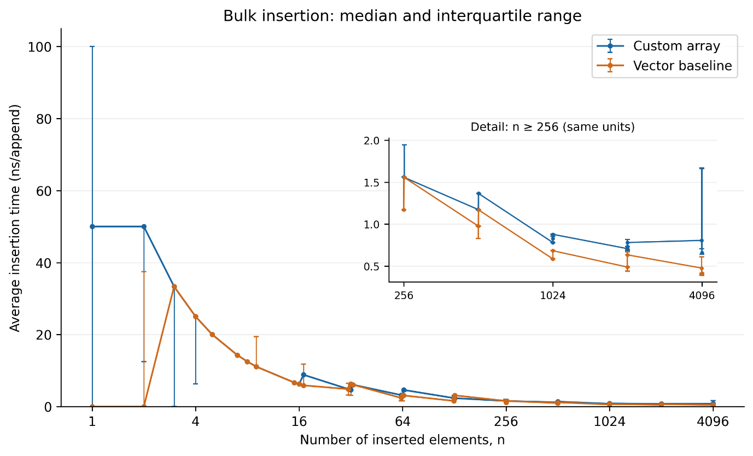

These sub-nanosecond values are averages calculated by dividing a timed insertion batch by its number of elements. They do not mean that the clock directly measured individual insertions with sub-nanosecond precision. At (n=4096), the median total insertion times were 2,700 ns for the custom array and 1,700 ns for the baseline. These short measurement intervals also make timing overhead and system variability relevant limitations.

The overall result is consistent with the distinction between worst-case and amortised complexity. Both structures perform (O(n)) model work across (n) appends, but the amount and organisation of that work differ. The custom array repeatedly checks migration state and transfers individual elements. The baseline performs many simple appends between its growth events. For inexpensive elements such as integers, occasional bulk relocation can be efficient enough to produce better overall throughput.

Allocated Storage
The storage measurements show the cost of retaining both buffers during migration. At (n=4095), the custom array held 49,152 bytes of allocated element storage, compared with 16,384 bytes for the baseline. The custom structure therefore used three times as much allocated element storage at this size.

At (n=4096), custom storage fell to 32,768 bytes after migration completed and the old buffer was released. Baseline storage remained at 16,384 bytes. Completing migration reduced the custom array’s allocated storage by one-third, although it still used twice as much as the baseline.

Table 3: Allocated element storage at the measured input sizes, with a detailed comparison at 4,095 and 4,096 elements. Storage is expressed in kibibytes (KiB), where 1 KiB equals 1,024 bytes.
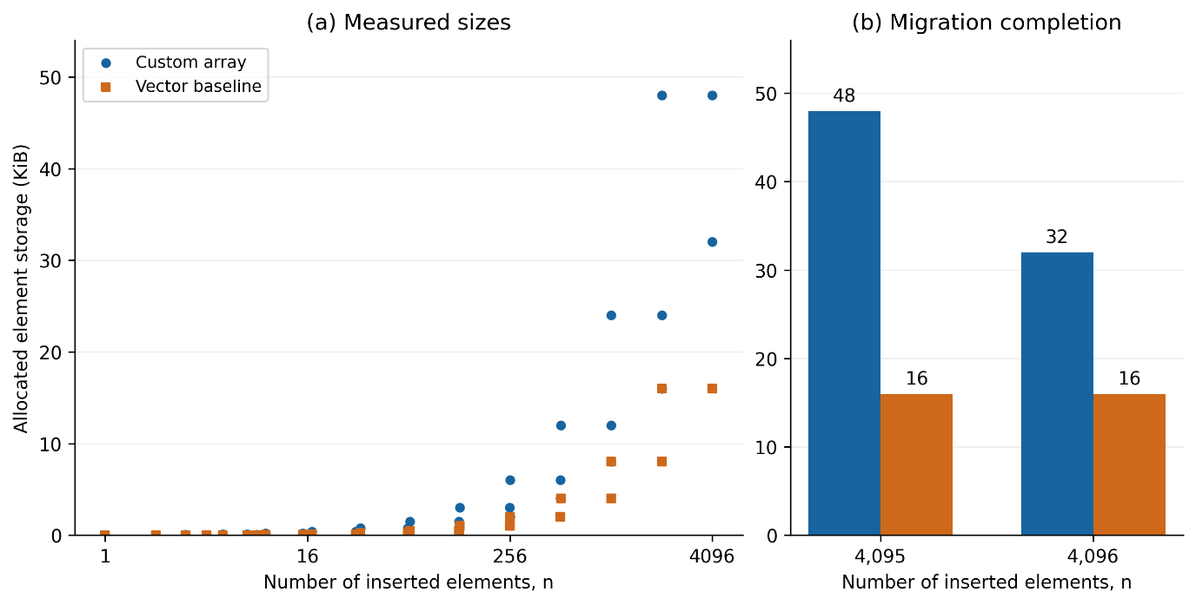

This pattern agrees with the implementation’s design. Incremental migration preserves old storage until every live element has been transferred. The resulting memory requirement remains (O(n)), but this asymptotic classification hides a substantial constant factor. The reported figures describe allocated capacity, including unused slots, rather than the memory occupied only by live values.

Random Indexed Access
The random-access results showed additional workload time at several sizes where migration remained active. For example, at (n=2047), the median elapsed time was 2,500 ns for the custom array and 1,700 ns for the baseline. At (n=2048), when the custom array had completed migration, the corresponding values were 1,600 ns and 1,650 ns. Similar patterns appeared around the 512-element and 1,024-element boundaries, as shown in Table 4.

Table 4: Median total random-access workload time around the 512-element, 1,024-element, and 2,048-element migration boundaries. Each panel compares the sizes immediately before, at, and after its boundary.
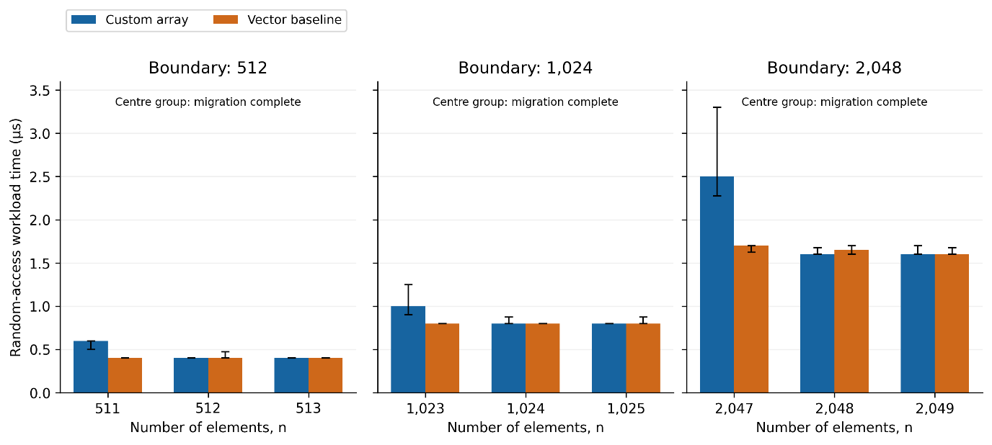

A larger difference appeared near the maximum tested size. At (n=4095), the custom array’s median access-workload time was 9,050 ns, compared with 3,300 ns for the baseline. The custom workload therefore took approximately 2.74 times as long. At (n=4096), the medians were much closer: 3,300 ns for the custom array and 3,200 ns for the baseline.

These changes are consistent with the additional access path used while migration remains active. Once migration finishes, the implementation can return elements directly from the current buffer. However, the experiment does not isolate the effects of branching, generated machine code, or cache behaviour. These are possible explanations rather than directly measured causes.

The results also do not show that every migrating state produces the same overhead. At (n=1025), for example, both structures recorded a median access-workload time of 800 ns. The position within a migration phase and measurement variability may affect the observed difference. The small differences at completed migration boundaries should therefore be interpreted cautiously.

Individual Insertion Latency
The individual-latency results were mixed. At (n=1024), the median of the ten trial maximum append latencies was 100 ns for both structures. At (n=1025) and (n=2048), the corresponding medians were 100 ns for the custom array and 200 ns for the baseline. At (n=4096), the custom array again recorded 100 ns, compared with 200 ns for the baseline.
Table 5: Distribution of trial maximum append latencies at input sizes 1,024, 1,025, 2,048, and 4,096. Each point represents the maximum measured append latency from one trial.
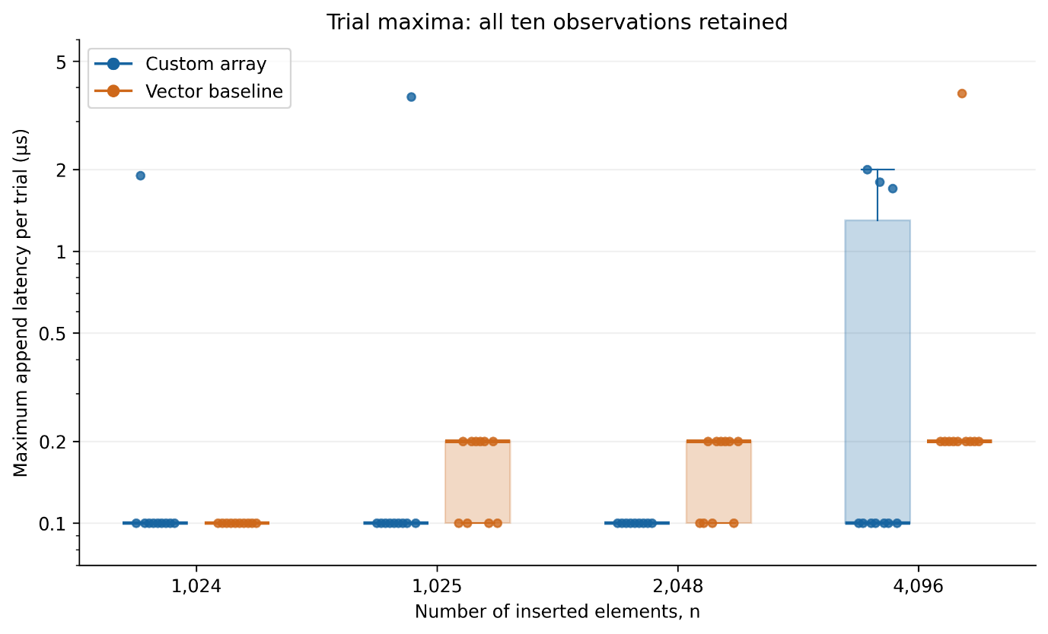

Although these selected sizes appear favourable to the custom array, this pattern was not consistent across the dataset. At (n=2049), the median trial maximum was 1,900 ns for the custom array and 200 ns for the baseline. At (n=4095), the corresponding values were 1,850 ns and 200 ns. The selected figure therefore illustrates some comparisons rather than establishing a general latency advantage.

Measurement resolution strongly limits the interpretation of these results. The recorded median insertion latency was zero in 661 of the 700 rows. Twenty of these rows represent empty inputs, for which no insertion was measured. Among the remaining 680 rows, 641 still recorded a median insertion latency of zero. Most recorded 95th- and 99th-percentile values were 100 ns.

A zero duration for a measured insertion does not mean that the operation took no time. It indicates that the timing method did not resolve the duration adequately. Nanosecond units therefore should not be mistaken for nanosecond measurement precision. These measurements cannot establish a reliable difference in typical individual insertion latency, even where the trial maxima differ.

Discussion and Limitations
The experiment demonstrates that improving a worst-case operation bound does not necessarily improve practical speed. The custom structure distributes element migration as intended, but this introduces ongoing work and greater allocated capacity. For the tested integer workload, ordinary std::vector growth generally provided better bulk throughput and lower storage requirements.

The random-access measurements also show why the array’s internal state matters. At some sizes immediately before migration completed, the custom structure took noticeably longer to execute the access workload. At completed migration boundaries, its results were often close to those of the baseline. This supports the expectation of migration-dependent access overhead, although the experiment does not identify its precise hardware-level causes.

The latency findings illustrate the limits of both the computational model and the measurement method. Under the stated model, allocating a buffer is treated as a constant-time operation, but its elapsed time can vary in practice. Scheduling, allocation behaviour, paging, and other system activity may contribute to observed spikes. Because the results store only latency summaries, it is not possible to identify which insertion produced a maximum or determine whether that operation allocated memory. The available measurements therefore cannot reliably attribute individual spikes to resizing.

Several methodological limitations restrict the conclusions. The study covers one execution environment, one stored type, and at most 4,096 elements. It does not establish behaviour for much larger workloads or expensive user-defined objects. The benchmark also always measures the custom structure before the baseline, which may introduce systematic order effects. Ten repetitions help expose variability but do not remove these concerns. Furthermore, the short bulk timing intervals and frequent zero-valued individual timings limit the precision of performance comparisons.

A stronger follow-up would alternate or randomise measurement order, test larger sizes and additional element types, record the complete execution environment, and preserve raw latency samples with growth-event markers. Bulk measurements should run long enough to reduce the relative influence of timing overhead. Operation counters could also verify the migration bound independently of elapsed time. Original CSV outputs should be retained so that large integer checksums can be checked without Excel’s numerical rounding.

Within these limitations, the results support a trade-off between bounded element-transfer work and practical overhead. The custom array generally required more time for bulk insertion and more allocated storage, while access performance depended partly on migration state. Some selected sizes showed lower median trial maximum append latencies, but the complete dataset and timing-resolution limitations prevent a general claim of superior latency. The empirical study therefore complements the theoretical analysis by showing costs and measurement constraints that asymptotic notation alone does not describe.

The Use of Artificial Intelligence
Tools Used and Their Contribution
I used ChatGPT and Codex throughout this project, with different responsibilities assigned to each tool. ChatGPT helped me organise the implementation requirements into a structured prompt, understand how to run the repository’s programs, and draft the written report. Codex carried out the main implementation work, including the resizable array, baseline, testing code, empirical study program, and supporting repository documentation. ChatGPT also assisted with analysing the supplied results and preparing figures.

AI therefore contributed substantially to both the code and its explanation. My contribution included defining the requirements, reviewing the proposed implementation approach, personally running the programs and tests, collecting experimental results, and reviewing the explanations produced from those results. I did not record the exact number of prompts or time spent using each tool, so this description represents their approximate involvement.

Planning, Implementation, and Independent Execution
Before implementation, I used ChatGPT to turn the assignment requirements into a plan that Codex could follow. The requirements included a vector-like data structure with bounded element-transfer work per append, a baseline comparison, separate testing and benchmarking programs, reproducible input data, and instructions for running the repository.

I initially submitted the implementation request to Codex using /plan. This allowed me to review and edit its proposed approach before asking it to implement the project. Reviewing the proposal helped me consider the organisation of the repository and the relationship between the implementation, tests, and empirical study before code was generated.

After implementation, I personally built and ran the programs, executed the tests, and performed the empirical study. I occasionally asked ChatGPT for help interpreting the execution instructions and applying them in Visual Studio Code. Running the programs myself helped me understand the workflow and check the outputs directly rather than relying solely on an AI-generated statement that execution had succeeded.

The tests passed during my execution, and the benchmark produced results for analysis. However, passing tests does not establish that every possible failure has been covered. Likewise, using a detailed prompt helped communicate the requirements but did not guarantee that the implementation or its explanation was correct. Both still required checking.

The Use of Artificial Intelligence – Problems with AI Assistance

Interpreting Individual Insertion Latency
One problem concerned the interpretation of insertion-latency measurements. The earlier AI-assisted report draft stated that a zero recorded latency indicated that the timing method could not adequately resolve an operation’s duration. This explanation was incomplete because the dataset also included empty-input trials, where no insertion occurred.

The revised analysis separated these cases. In results.xlsx, 661 of the 700 rows recorded a median insertion latency of zero. Twenty rows represented empty inputs. Among the remaining 680 rows, 641 still had a recorded median insertion latency of zero. The revised explanation therefore distinguished the absence of an operation from an operation whose duration was not resolved by the measurement method.

This correction showed why an AI-generated explanation can sound reasonable while overlooking an important detail in the dataset. It also reinforced the distinction between reporting time in nanoseconds and achieving nanosecond measurement precision.

Treating Spreadsheet Checksums as Exact Evidence
A second problem arose when adapting the analysis from CSV to Excel. The earlier draft reported agreement between paired checksums as evidence supporting the comparison. Carrying that statement into the spreadsheet-based analysis without qualification would have been misleading because Excel had rounded the large integer checksum values.

The revised draft removed the claim that the workbook could establish exact checksum equality. It instead explained that exact comparison requires the original benchmark CSV associated with the workbook, read in a way that preserves the integer values. The timing and storage columns could still be analysed, but the rounded checksum cells could not provide the same validation evidence.

This issue demonstrated that changing a file format can affect the reliability of fields. AI assistance did not remove the need to understand how the software represented the data.

What I Understood vs What I Took on Trust
My understanding of the central design is that the custom array distributes relocation work across successive appends. During migration, it retains an old buffer and a replacement buffer, moves at most one existing element per successful append, and uses migration state to determine where an indexed element is stored. This explains the intended bound on element-transfer work and the additional storage required while migration is active.

I also understand the main distinction between throughput and latency. Timing an entire insertion loop measures the overall cost of constructing the array, while timing each append separately investigates variation between individual operations. A better theoretical worst-case bound does not automatically produce better throughput or a strict elapsed-time guarantee on a real computer.

My confidence is more limited in the detailed C++ mechanisms used for raw storage, object lifetime management, copying, moving, and exception handling. I relied partly on Codex’s implementation and the available tests for these aspects. I have not independently proved their correctness for every possible element type, allocation failure, or exception path.

Similarly, explanations involving branching, cache behaviour, allocation, or operating-system scheduling remain possible interpretations of the measurements. The benchmark did not directly measure these causes. I therefore treat them as hypotheses rather than established explanations.

AI assistance made it possible to develop and document the project more efficiently, but reviewing its output remained part of the work. The project required checking numerical claims against the supplied results, recognising measurement limitations, and distinguishing what the implementation was designed to guarantee from what the experiment actually demonstrated.

